**Robust Design on the Missile Shooting Problem via Taguchi Optimization**

Hao Li

***Abstract***

*In real engineering problems, uncertainties from different aspects always give rise to the variation in the responses of interests, which may cause unexpected failure to the system. Taguchi design turns out to be an effective and efficient robust design of experiments method to find out the best sets of control factors (design variables) to reduce the variation of responses caused by the noise factors (variations). Typical Taguchi design is a manual process based on individual experience and historical data, which is time consuming and impossible for young engineers without much expertise. However, typical Taguchi design can be formulated as an optimization problem to maximize signal-to-noise (S/N) ratio of responses of interests. S/N ratio is a statistical measurement calculated according to design of experiments. Several responses can be considered to build up a multi-objective problem. In this project, an automatic Taguchi design process using optimization techniques will be developed based on a missile shooting problem. Orthogonal arrays will be used for design of experiments. Method of least squares is used as the regression model for the responses and S/N ratio, which will be used for building up objective function and constraints. Multiple responses will be considered by applying weighting functions. This is an iterative optimization process starting with a local design space. The local design space will keep moving and updating till the optimum is found. MATLAB optimization toolbox will be used to get the optimum results.*

**1. Motivation and Problem Description**

Real engineering problems are full of uncertainties, which may come from different aspects, such as material properties, loading conditions, temperature, human factors and etc. These uncertainties always cause variation in the responses of interests, which may give rise to the risks of failure of a system. However, there are an increasing number of methods proposed to get robust design.

Taguchi design was widely used in the manufacturing industry as a quality control and design tool in many US and European industries since the 1980s. According to Taguchi, quality loss is defined as the total loss imparted to the society from the time a product is shipped to the customer. In order to minimize loss, products should be designed to achieve optimal performance with minimal variation in this performance. Taguchi’s fundamental concept rests on the importance of economically achieving high quality, low variability and consistency of functional performance [1, 2]. However, the typical way for Taguchi design needs a lot of professional judgments and individual experience. This manual process will greatly affect the effectiveness for product development. Thus, a programming package is needed to transfer this manual process into an automatic one. How to achieve the professional judgments and individual experience by computational power is the challenge for this process.

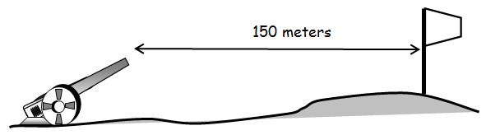

**Figure 1.1 Missile shooting problem**

Missile shooting problem is shown in Fig. 1.1. The flag is the target that needs to be shot, which requires high accuracy. However, uncertainties from weight of missiles, force and angel to launch the missiles, and environment factors, make each shoot different. How to get the robust design becomes a significant factor to consider. The force applied on missile and the angel for launching turn out to be the control factors for this system. There are some variations for mass, angle and force for each shoot, which leads to the uncertainty for the responses, distance y and flying time t, defined by Eq. (1.1) and (1.2). The missile should hit the target which is 150 meters away and the flying time should be within 1 to 5 seconds. Tab. 1.1 shows the detail for control factors and noise factors. The goal is to find the best set of design variables, force F and angle $θ$ so that the design is the most robust one.

$y=\frac{1}{g}{\left(\frac{F}{m}\right)}^{2}\sin{2θ}$ (1.1)

$t=\frac{2F}{mg}\sin{θ}$ (1.2)

**Table 1.1 Control and noise factors**

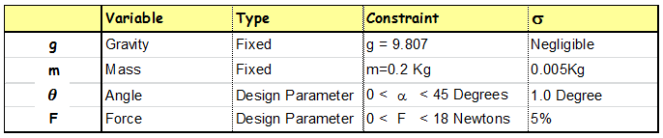

**2. Design Optimization Problem Statement**

**2.1 Design Variables**

In the missile shooting example, there are two design variables or control factors which can be controlled, force F and angle $θ$. The force F ranges within 0 to 18N and the angle $θ$ can increase from 0 to ${45}^{°}$ shown in Tab. 1.1. They are also noise factors coming from loading conditions with standard deviation $1^{°}$ and 5%. The mass m of the missile is also uncertain, with mean 0.2kg and standard deviation 0.005kg. This is the uncertainty from material property. Uncertainty from environment is negligible.

**2.2 Objective Function**

There are two responses in this example, distance y and flying time t, defined by Eq. (1.1) and (1.2). In order to get the robust design for both distance and flying time, the corresponding S/N ratios need to be maximized. The S/N ratio is defined by Eq. (2.1). $\overline{Y}$ and $σ$ represent the mean value and standard deviation of the response, which will be calculated from samples using design of experiments.

$\frac{S}{N}=10log⁡\left(\frac{{\overline{Y}}^{2}}{σ^{2}}\right)$ (2.1)

Design of experiments (DOE) is performed according to the L9 orthogonal array shown in Tab. 2.1 for both distance y and flying time t. There are 3 levels for both control factors and noise factors. Thus, there are 9 cases by changing control factors and 9 replicates for each case according to noise factors. Based on the experimental data, mean, standard deviation and S/N ratio are calculated for each case. The method of least squares is used to get regression models for both mean value and S/N ratio for distance y and flying time t shown in Eq. (2.2) to (2.5)

$\hat{\overline{Y}}=a_{0}+a_{1}F+a_{2}θ+a_{3}F∙θ$ (2.2)

${\hat{Y}}_{SN}=b_{0}+b_{1}F+b_{2}θ+b_{3}F∙θ$ (2.3)

$\hat{\overline{t}}=c_{0}+c_{1}F+c_{2}θ+c_{3}F∙θ$ (2.4)

${\hat{t}}_{SN}=d_{0}+d_{1}F+d_{2}θ+d_{3}F∙θ$ (2.5)

**Table 2.1 L9 orthogonal array**

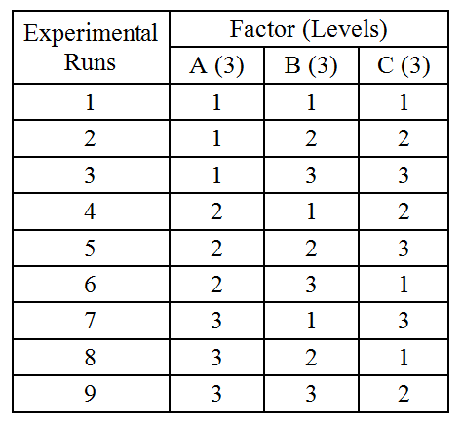

The goal is to maximize the S/N ratio to get robust design. Two responses make this problem a multi-objective optimization problem. The weighted sum method is used for objective function shown in Eq. (2.6).

$$maximize: U=w_{y}∙{\hat{Y}}_{SN}+w_{t}∙{\hat{t}}_{SN}$$

where $w_{y}$ and $w_{t}$ are the weights for distance and flying time.

**2.3 Constraints**

Constraints can be easily determined based on Eq. (2.2) and (2.4). There are an equality and two inequality constraints shown below

$\hat{\overline{Y}}=150$ (2.6)

$1≤\hat{\overline{t}}≤5$ (2.7)

**2.4 Standard Form**

Find $X={\left[x_{1} x_{2}\right]}^{T}={[F θ]}^{T}$

Minimize: $U=-\left(w_{y}∙{\hat{Y}}_{SN}+w_{t}∙{\hat{t}}_{SN}\right)$

$=-w_{y}∙\left(b_{0}+b_{1} x_{1}+b_{2}x_{2}+b_{3} x_{1}∙x_{2}\right)$

$$-w_{t}∙(d_{0}+d_{1}x_{1}+d_{2}x_{2}+d_{3} x_{1}∙x_{2})$$

Subject to: $a_{0}+a_{1}x_{1}+a_{2} x_{2}+a_{3}x_{1}∙ x_{2}-150=0$

$1-c_{0}-c_{1}x_{1}-c_{2}x_{2}-c_{3}x_{1}∙x_{2}≤0$

$c_{0}-c_{1}x_{1}-c_{2}x_{2}-c_{3}x_{1}∙x_{2}-5≤0$

$0≤x_{1}≤18$

$0≤x_{2}≤45$

**3. Solution Strategy**

Since the design space could be very large, solving the problem by one optimization may results in a local optimum, which totally depends on the initial starting point. However, getting useful starting point information is difficult, especially at the early stage of design exploration. In order to detect the global optimum, an iterative updating window strategy is used as the solution strategy. The flowchart is shown below in Fig. 3.1.

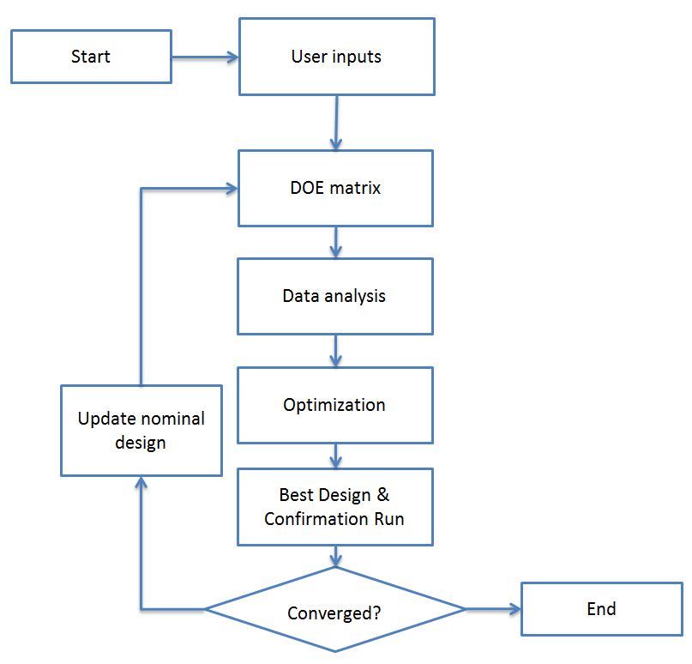

**Figure 3.1 Flowchart of updating window strategy**

Basically, a local design space is defined by the user, which is smaller than the entire design space. DOE is performed within this local design space to get the least squares regression model. Then optimization is conducted based on the regression model within the local range till the optimum is detected. Based on the optimum, a new local range is defined. This is an iterative process until the final optimum is found. During this process, the local range keeps moving until the optimum is focused within this domain. Then, this local range start becoming smaller till the solution is found. This process is shown in Fig. 3.2.

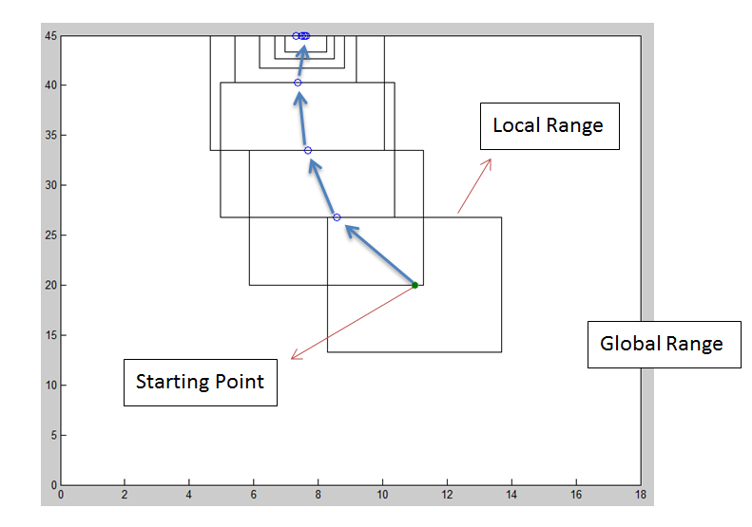

**Figure 3.2 Updating window strategy**

Fig. 3.3 shows the convergence criteria for this automatic Taguchi design. The basic idea is that either control factors or functions are converged, stop the iteration. Convergence of control factors means all the control factors are converged. So are the functions.

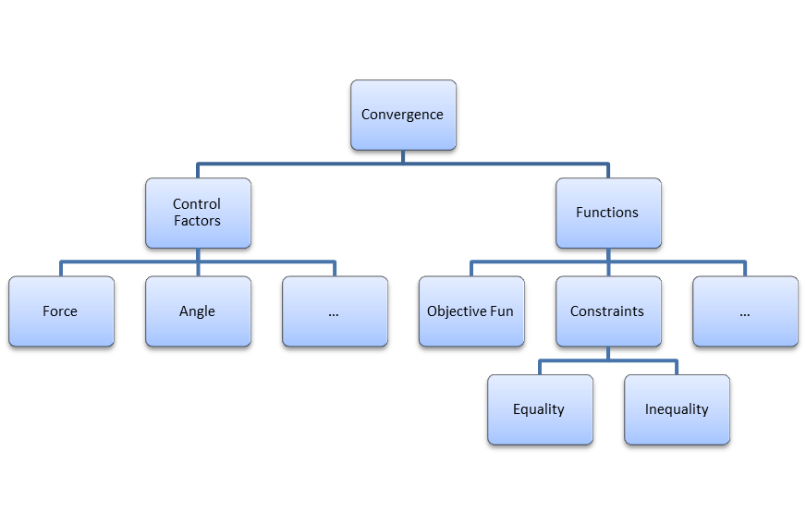

**Figure 3.3 Convergence criteria**

**4. Solution and Further Discussions**

Weights in objective function for distance and flying time are assigned as 0.8 and 0.2, since hitting the target needs much more reliability compared to flying time. Initial starting point is randomly chosen shown below in Eq. (4.1) and (4.2) because this is just a preliminary study of the missile shooting problem. Any prior information can be used to determine a good starting point. MATLAB optimization toolbox is used to solve the problem. Optimum solutions, convergence study, feasibility check, physical insight of the solution and further discussions are provided in the following part.

$F_{0}=11.0$ (4.1)

$θ_{0}=10.0$ (4.2)

**4.1 Optimum solutions and physical insight**

Optimization problem is solved using MATLAB optimization toolbox. Table 4.1 shows the optimum solutions. By applying force 7.727N, angle 39.369 degrees, most reliable design is obtained, which means once this design set is used to launch a missile, the uncertainty is reduced to the least. The optimum is within the simple bounds of design variables. The flying distance is 149.824m, which is very close to 150m. The error may come from computational method aspect or accuracy of regression model, therefore I would consider it as active. The inequality constraint of flying time hit the upper limit, so it is active as well. The optimum turns out to be a feasible design.

Table 4.1 Optimum solutions

|  |  |
| --- | --- |
| Variables | Optimum |
| F | 7.727 |
| $$θ$$ | 39.369 |
| obj | 19.540 |
| Distance | 149.824 |
| Time | 5.000 |

**4.2 Convergence Study**

The optimum solutions are obtained after 18 iterations. The reason for that is the stop criteria of design variables is met. The iteration history of design variables, responses, objective function and constraints are shown below from Figure 4.1 to Figure 4.4. From Figure 4.2, the distance is close to 150 and the flying time hits the upper bound, 5 seconds. The objective function value keeps decreasing till the converged value shown in Figure 4.3. At the first iteration, the objective value increases a little bit because the initial starting point violates some of the constraints. Then the optimizer keeps improving the results till the optimum is found. Equality constraint and upper bound inequality constraint are close to zero and the lower bound inequality constraint is negative. It turns out that converged solutions are obtained.

Figure 4.1 Iteration history of design variables

Figure 4.2 Iteration history of responses

Figure 4.3 Iteration history of objective function

Figure 4.4 Iteration history of constraints

**5. Summary**

In this project, the goal of integrating optimization techniques with Taguchi design to get an automatic robust design process is achieved. This methodology is successfully applied on a preliminary missile shooting problem. The robust design is found after optimization using MATLAB optimizer. Convergence study, feasibility check and physical insight of the solution are discussed. It turns out that this method is an effective way to get the design with minimum uncertainties. More research needs to be done on the regression model in order to increase the accuracy.

**References**

[1] Packianather, M. S., Drake, P. R., and Rowlands. H., "Optimizing the parameters of multilayered feedforward neural networks through Taguchi design of experiments." *Quality and reliability engineering international,* Vol. 16, No. 6, 2000, pp. 461-473.

[2] Zhang, J. Z., Chen, J. C., and Kirby, E. D., "Surface roughness optimization in an end-milling operation using the Taguchi design method." *Journal of materials processing technology,* Vol. 184, No. 1, 2007, pp. 233-239.